Accessing Case Study Material Online
Prepared by Rob Schadt rschadt@bu.edu
- The Case Study Center for Teaching in Science
Go to http://sciencecases.lib.buffalo.edu/cs/
Click in the lower middle of the page on Case Collection.
This will bring you to the Case Collection page. In the middle of the page you see the keyword search area:
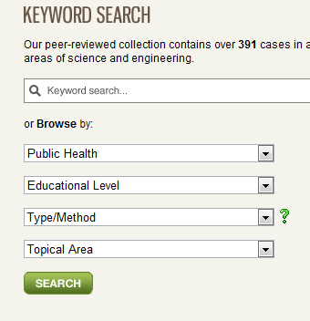

You can search by key word or you can “Browse by” area, educational level, etc. and open up the drop down menus. In the image to the left I selected Public Health. I can search all the public health related cases by typing in public health and clicking Search. The Green question mark next to “Type/Method” will bring you to this page describing different ways to use cases and it provides appropriate cases that can be used for this method. Clicking the green question mark will take you to: http://sciencecases.lib.buffalo.edu/cs/collection/method.asp>

- The Electronic Hallway (http://hallway.evans.washington.edu
This is a site that many professors in the US use that is oriented towards issues of public policy. It is run out of the School of Public Affairs at the University of Washington. It is very oriented to the US and therefore may not be too relevant. You do not need to be a member to search cases. You will find the search feature easy to use…. You do need to be a member to access the cases. Membership is free so feel free to join. Let me know if there is something that interests you and I will access it for you.
If you go into case teaching you will see some very well done materials for an integrated management curriculum. http://hallway.evans.washington.edu/case-teaching/integrated-management-curriculum
- EECH – The Case for Learning http://www.ecch.com/educators/
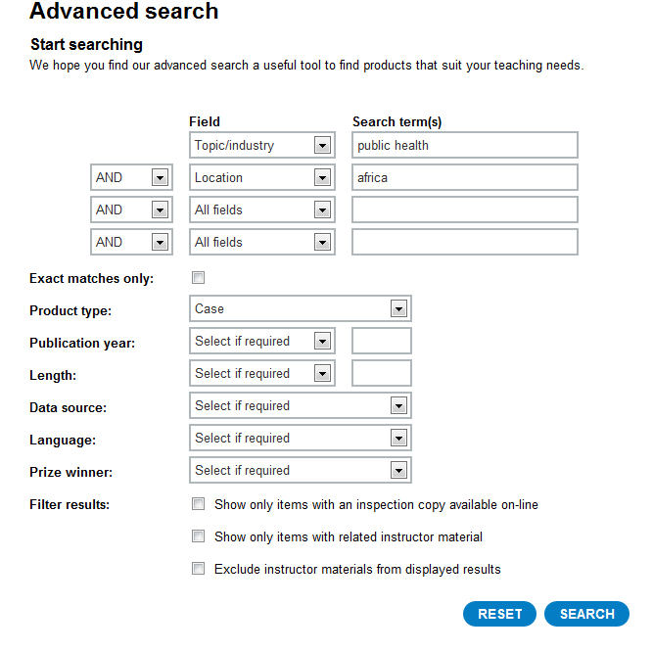
This is a good source of cases; however , these cases are sold and have some restrictions in use. The cost on average $3 per copy. You can brose and see if there is something that interests you. The search engine is a little more advanced but not hard to use. Here is the advanced search:

As you see here I have put in “Public Health” for topic and “Africa” for location and “case” a product type. I got 13 possible cases. I gave you one or two of these already I think…

If you browse these and find one you want let me know and I will purchase it for you.
Below is a detail of one of the cases that came up…

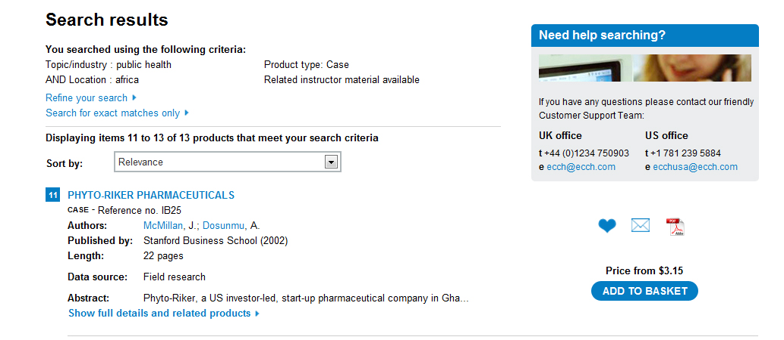

And here if I click on the link for Riker Pharmaceuticals I get these details.
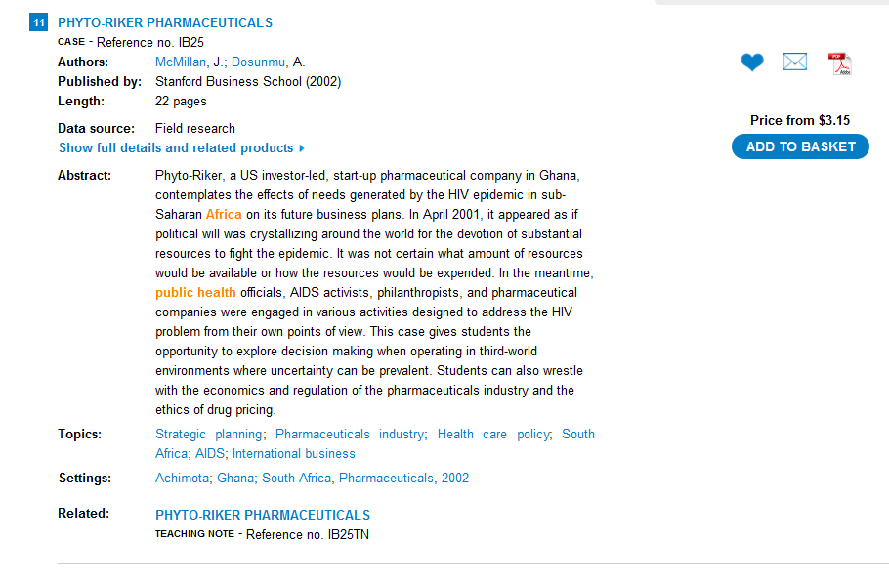
Again if you think there is a case you are interested in I will access it and bring it to you next month. In this as in all case collections you need to first browse and then determine if there is something of interest. If so I will help from that point.
Here is a link for free cases available from the Stanford School of Business provided through EECH… http://www.ecch.com/educators/casemethod/resources/freecases/stanfordfreecases
Here are some other websites that you might be interested in…
http://www.mhealthinfo.org/projects_table
This website aims to offer an up-to-date source of information and a platform for sharing knowledge on the current use, potential and limitations of mHealth in low-resource settings.
http://www.africanplanningschools.org.za/
Founded in 1999, the Association of African Planning Schools (AAPS) is a voluntary, peer-to-peer network of African institutions which educate and train urban and regional planners.

South African case study collection > University of Pretoria
http://web.up.ac.za/default.asp?ipkCategoryID=16579&sub=1 ..
South African case study collection ... Education, Engineering, Built Environment & IT, Gordon Institute of Business Science, Health Sciences, Humanities, Law ...
http://www.globaleducation.edna.edu.au/globaled/go
Teacher resources supporting the integration of a global perspective across the curriculum
A great teacher tools page (look at case studies)
http://www.globaleducation.edna.edu.au/globaled/go/pid/57
This site looks very promising on social and behavioral and gender issues:
http://www.genderjustice.org.za/ Also on this site:

Working with Men and Boys:
www.genderjustice.org.za/menengage-africa-case-studies-collection
File Format: PDF/Adobe Acrobat
This collection of case studies reflects work done by a large group of people. ... Men for Gender Equality Now, Johns Hopkins Health and Education South Africa,
http://www.biomedcentral.com/1472-698X/10/S1/S1
Science-based health innovation in Sub-Saharan Africa.

Research Databases at Case Western Reserve University This is eh URL for Health Sciences. Many things are restricted, but not all…
http://library.case.edu/databases/RDBindex.aspx?cat=294

Case Study: the South African Cash Circulation Model – at the Forefront of Innovation http://countingoncurrency.com/wp/2011/01/25/cash-circulation-case-study/
Datasets for Teaching…very good for Biostatistics… Several dozen case studies with questions and hints. ... Data: a Collection of Problems from many Fields for the Student and Research Worker
http://www.statsci.org/datasets.html
Case: ICF for TB in rural Zambia and peri-urban South Africa (ZAMSTAR)
http://www.tbhiv-create.org/sites/default/files/ICF%20in%20peri-urban%20SA%20and%20rural%20Zambia%20(ZAMSTAR).pdf
African Studies Collection
http://www.ascleiden.nl/Publications/AfricanStudiesCollection.aspx
http://www.ascleiden.nl/Publications/AfricanStudiesCollection.aspx
The sustainable sanitation alliance publishes case studies of sustainable sanitation projects to demonstrate the wide range of possible sanitation systems.

Ethics
- www.onlineethics.org This University of San Diego case site developed by philosophy professor Robert Ladenson is a collection of 100 ethics cases. The site has many interesting features including online surveys.

Medicine
- Epidemiology Case Studies from the Centers for Disease Control (CDC) are available at http://www.cdc.gov/eis/casestudies/casestudies.htm and http://www2a.cdc.gov/epicasestudies/.
- Problem-Based Learning Modules: List of problem-based learning modules available for a fee from the Southern Illinois University School of Medicine.
- University of Pittsburgh Dept. of Pathology Online Case Studies: Searchable database of pathology case studies.
- Joint Program in Nuclear Medicine Teaching Cases: These cases, developed by the Nuclear Medicine Divisions of the Harvard Medical School teaching hospitals, can be searched by browsed by title or author. Comments on the cases can be posted to the Web site.
- EnviroDx--Clinical Cases in Environmental Medicine: EnviroDx provides access to well developed and well designed multimedia, computer-based cases on environmentally related diseases. Currently there are two cases available on this website.
The Outbreak: This fictionalized case addresses the ethical issues confronting governments, NGOs, and pharmaceutical companies when faced with an epidemic.
http://www.scu.edu/ethics/dialogue/candc/cases/outbreak.html
Cases in Medical Ethics (mostly US based issues)
http://www.scu.edu/ethics/publications/submitted/cirone/medical-ethics.html
Some very good general resources on case teaching
Very good resource on Case Teaching from University of Michigan
http://www.crlt.umich.edu/tstrategies/tscbt.php
A great resource page on case teaching from the University of Medicine and Dentistry of New Jersey
http://cte.umdnj.edu/active_learning/active_case.cfm

